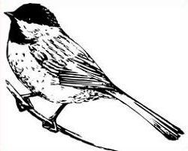  Made with love especially for you by  a member of  St. Croix Int’l Quilters |  | Made with love especially for you by  a member of  St. Croix Int’l Quilters
Made with love especially for you by  a member of  St. Croix Int’l Quilters |  | Made with love especially for you by  a member of  St. Croix Int’l Quilters

